


OrthoCFD App
Application Setup and Maintenance Guide
by Alejandro Matos Camarillo

Based on initial development by Uday Tummala
Computational Fluid Dynamics Lab, University of Alberta

Supervisors:
Dr. Carlos Lange
Dr. Manuel Lagravere


Date: June 1st, 2025
Table of Contents
1 Introduction 3
1.1 Methodology 3
2 Quick Start Guide 4
2.1 Welcome Screen 4
2.2 Patient Scan Upload 5
2.3 Patient Information Review and Scan Previews 7
2.4 Analysis and Results 7
3 Troubleshooting 10
3.1 Inlet and Outlet of Geometry Are Incorrectly Positioned 10
3.2 How to log out, shut down, and/or open terminal in “locked down” cfdapp profile 10
3.3 Error While Saving Data to External Drive 10
3.4 Airflow Simulation Taking Too Long (e.g. Over 30 Minutes) 10
4 Making App Modifications 11
4.1 Edits to Be Completed 11
4.2 Edit/Add Contributor List 11
4.3 Editing App Name, Theme, Appearance, Path Configurations 11
4.4 How to incorporate Minimum Cross Sectional Area calculation script 11
4.5 How to edit question mark (tooltip) contents 12
4.6 Editing airway segmentation (prediction) parameters 12
4.7 Editing CFD simulation parameters 12
5 System Setup and Configuration 13
5.1 Operating System Installation Steps 13
5.1.1 Language and Keyboard Settings 13
5.1.2 Network Configuration 13
5.1.3 Online Repositories 14
5.1.4 System Role 14
5.1.5 Partitioning 14
5.1.6 User Creation 14
5.2 Post-OS-installation Configuration 15
5.2.1 NVIDIA CUDA Installation 15
5.2.2 Software Environment Setup 17
5.3 Creating Restricted User Profile 21
5.3.1 User Creation and Autologin Setup 21
5.3.2 Setting display manager 21
5.3.3 Window Manager and Session Script Setup 22
5.3.4 Disabling UI Features and Keyboard Shortcuts 24
6 App Development Guide 28
6.1 Project Folder Structure 28
6.2 Overview of Main Modules 29
6.2.1 main.py 29
6.2.2 blender_ortho.py 29
6.2.3 paraview_ortho.py 30
6.2.4 gui/app.py 30
6.2.5 gui/utils 31
6.2.6 gui/config 31
6.2.7 gui/components 31
6.2.8 Other supporting files: geo_in.txt and sdir.txt 32
7 Troubleshooting 33
7.1 Python 33
7.2 Blender 33
7.3 OpenFOAM 33
8 Future CFD Application Improvements 34
8.1 Planned Features 34
8.2 Speculative/Early Research Items 34

- Introduction
Obstructive sleep apnea (OSA) is a condition that affects a significant portion of the population and is associated with health complications including poor growth in children, and cardiovascular problems. Orthodontic treatments such as palatal expansion or mandibular advancement can alter the upper airway geometry, potentially affecting airflow resistance. This creates a clinical need to assess the airway function before and after such interventions.
To support clinicians and researchers in evaluating these changes, an open-source tool was developed to automate computational fluid dynamics (CFD) simulations of nasal airflow. The goal is to make this tool accessible to healthcare professionals who do not have expertise in CFD or programming.
The first 3 chapters of this document provide a quick-start and troubleshooting guide. Chapters 4-8 provide a summary of the operating system configuration, installed software, disk partitions, and an overview of the GUI app’s folder structure and functionality, running on openSUSE Leap 15.6.
This document is intended for team members who would like to understand, maintain, or modify the CFD application.

Methodology
The OrthoCFD application guides users through an automated pipeline to evaluate nasal airflow using CFD. Clinicians can use it to assess airway changes from treatments like palatal expansion or mandibular advancement.
The workflow includes:
- Uploading a CT or CBCT scan in DICOM (.dcm) or NifTI (.nii.gz) format
- Segmenting the upper airway using a trained nnUNetv2 model
- Converting the segmentation into a 3D model using VTK
- Preprocessing the model with Blender
- Running CFD simulation with OpenFOAM
- Extracting and visualizing results using ParaView
This end-to-end process helps reduce reliance on manual steps and enables non-experts to perform airflow analysis reliably.

- Quick Start Guide

Welcome Screen
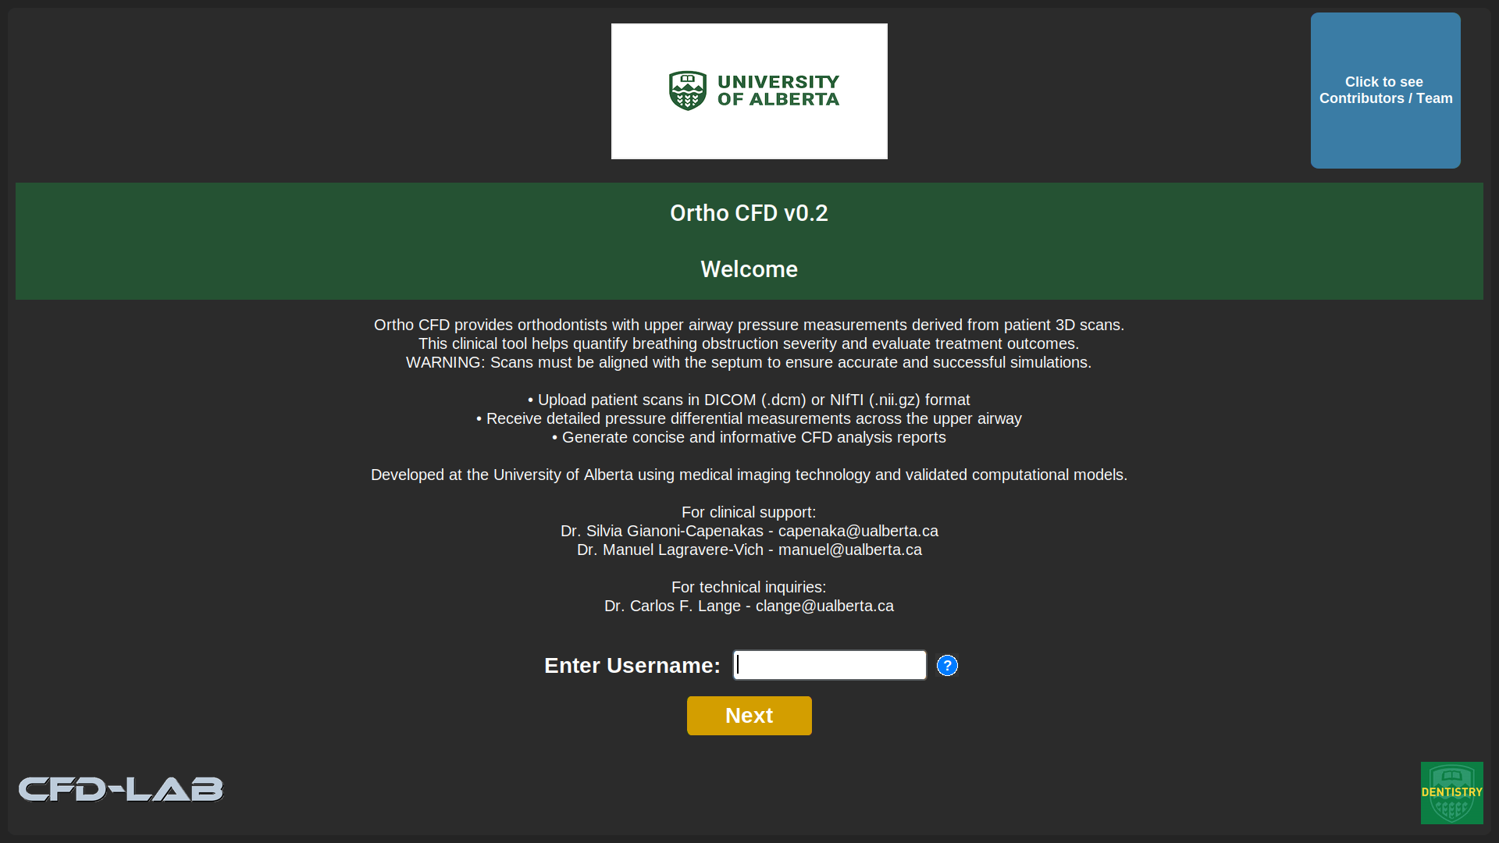
In this screen, the user must input their last name as their username with no spaces or capital letters and click on Next to proceed to the Patient Upload Screen. There is also the option to see the list of contributors and team members responsible for the development of the app when clicking on the blue square in the upper right side.

Patient Scan Upload
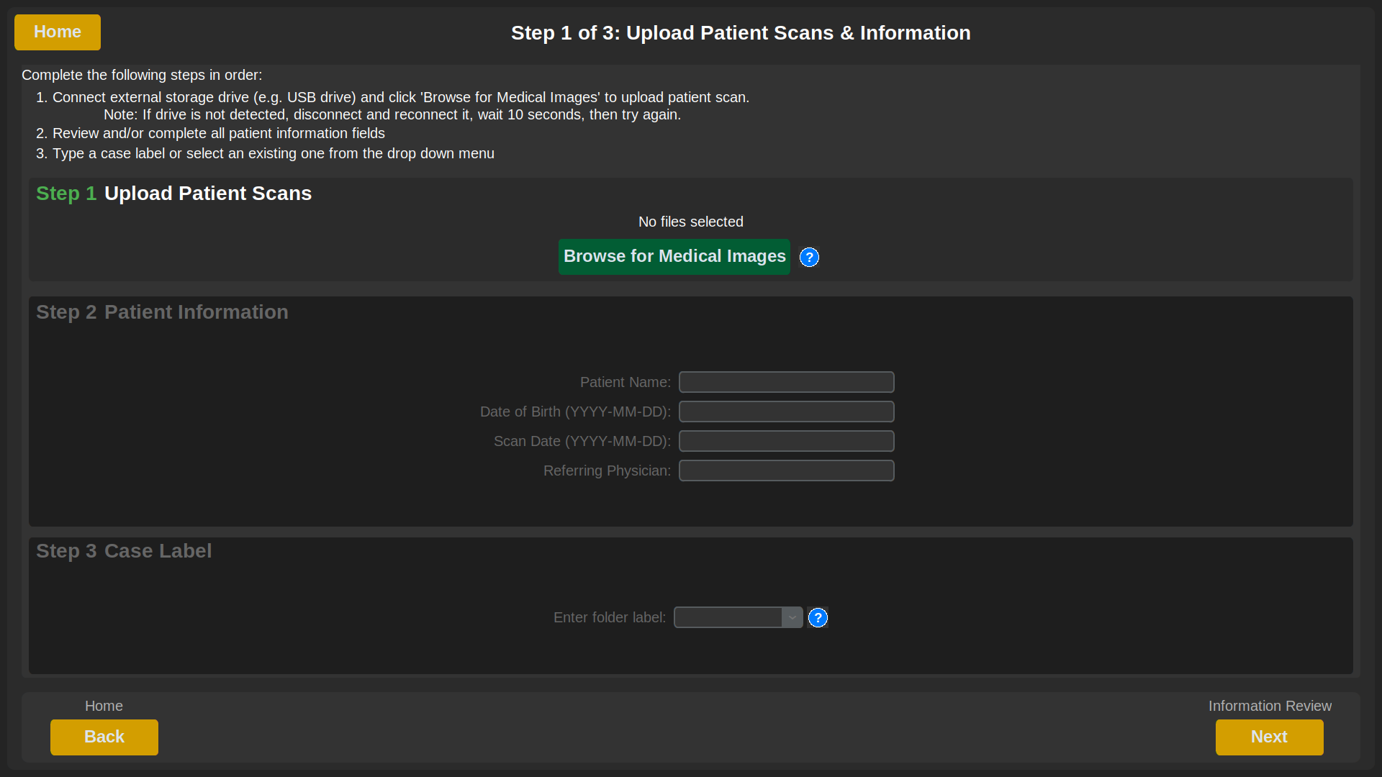
In the Patient Scan Upload step, the patient information is uploaded by first clicking on “Browse for Medical Images”
where the program looks for the medical image files (DICOM or NifTI) contained within an external drive inserted by the user.

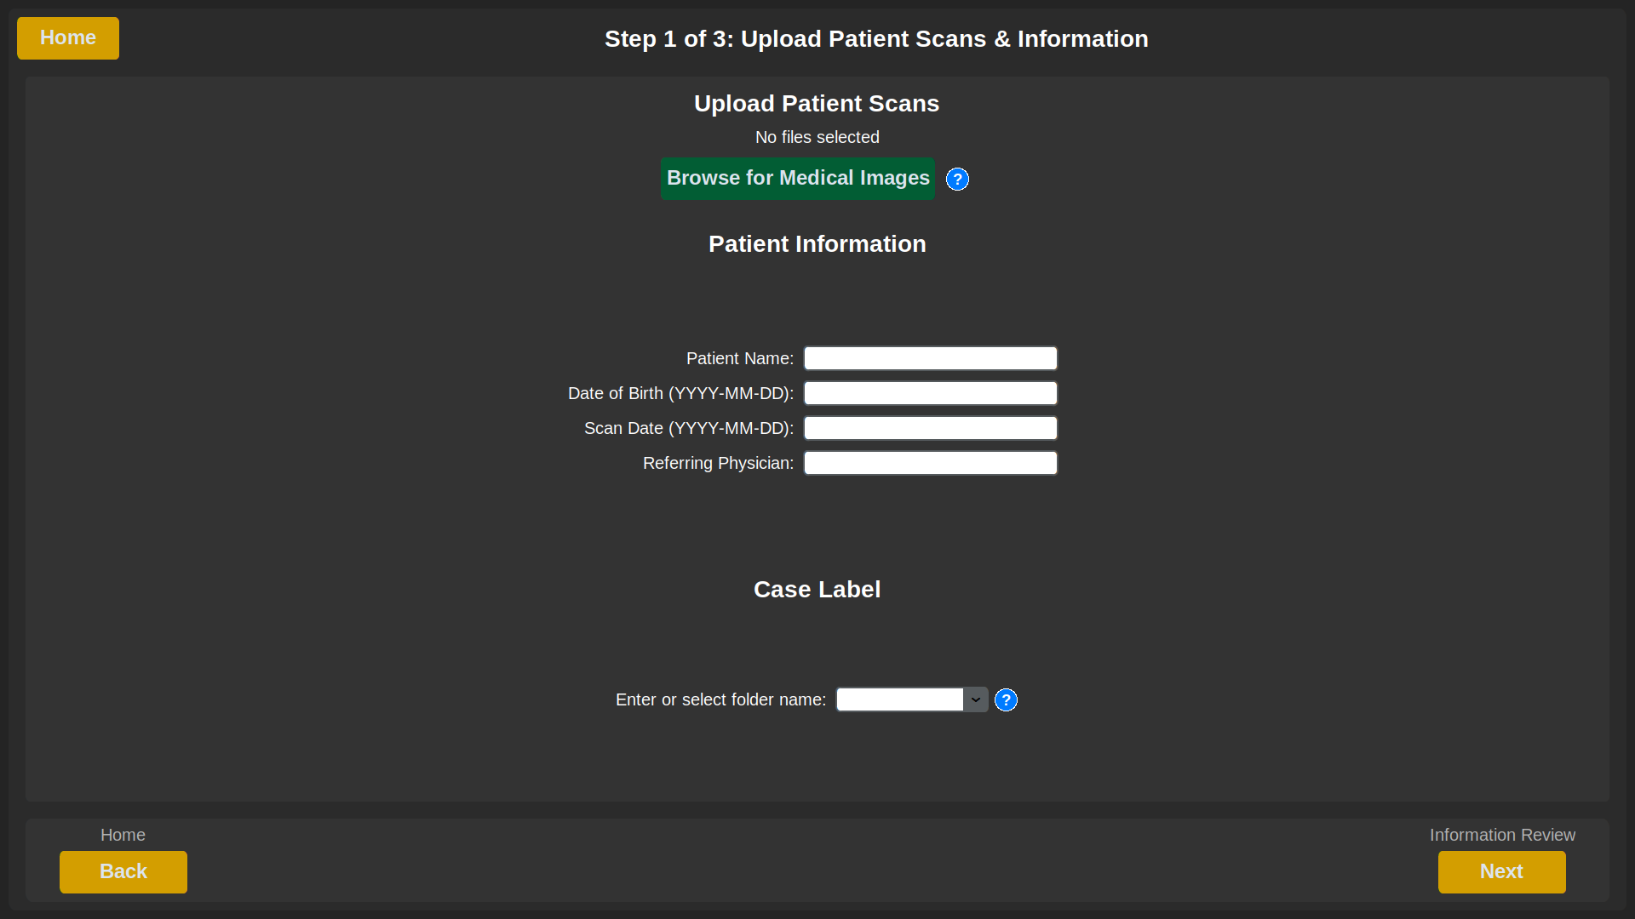
Steps:
- Click on Browse for Medical Images.

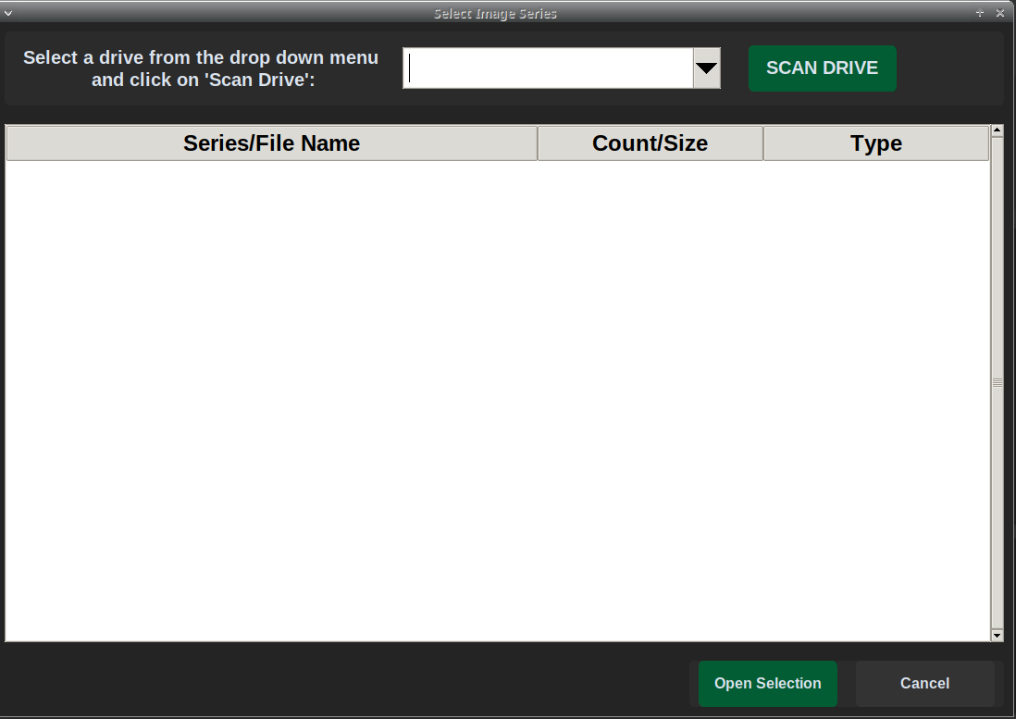
- A window will open where the user must select a drive from the drop down menu and then click on SCAN DRIVE. The software will automatically look for DICOM or NifTI files stored in the USB.

- Once the desired scan files are found, double click on them or click once and then click “Open Selection”.
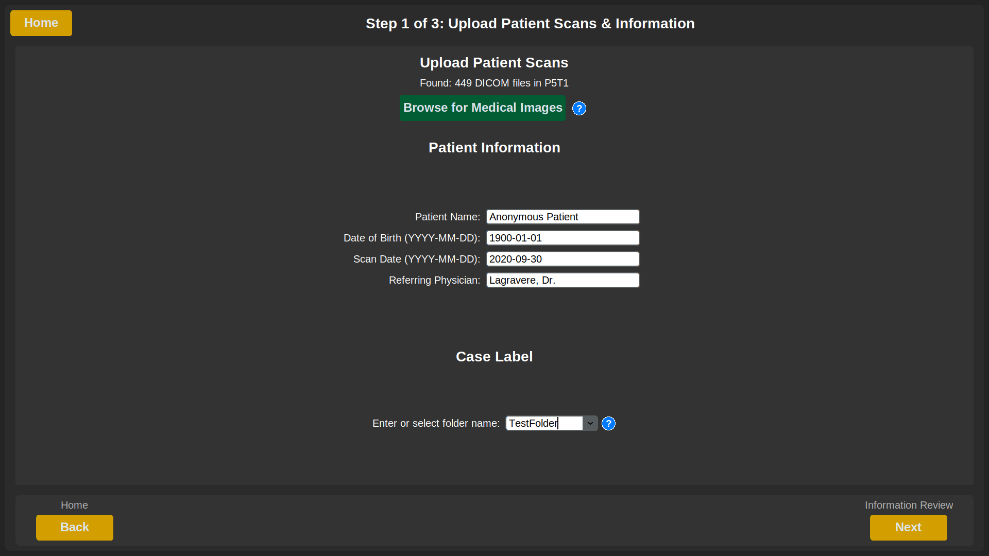
- For DICOM files, the patient information may auto-populate in the respective fields, if available. In the case of NIfTI files, the user must manually input the information.

- Type a descriptive case label or select an existing one from the drop down menu. This case label can be used to differentiate between slightly different cases for the same patient, or to differentiate between different anonymized patients
- Once everything is filled in, press Next to get to the Information Review tab

Patient Information Review and Scan Previews
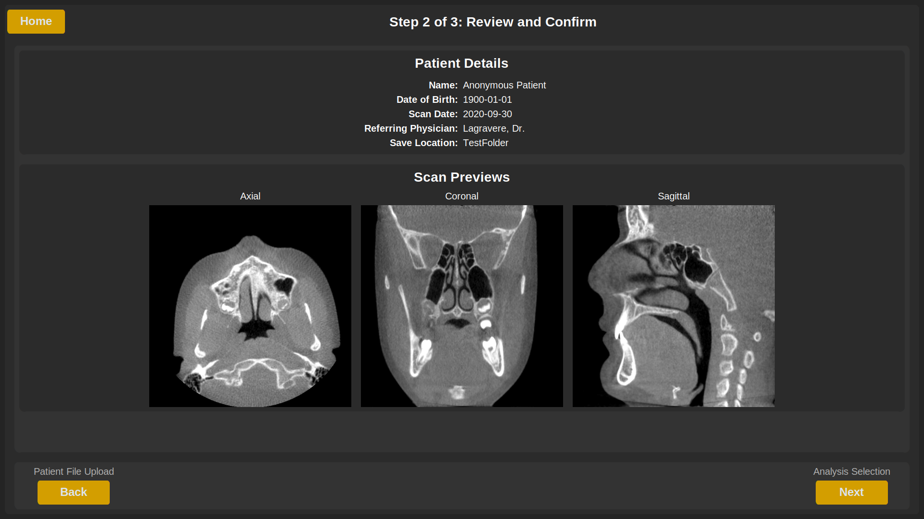
This screen is for making sure that the patient information is correct and that the medical images look as expected and are not corrupted or containing errors.

Analysis and Results
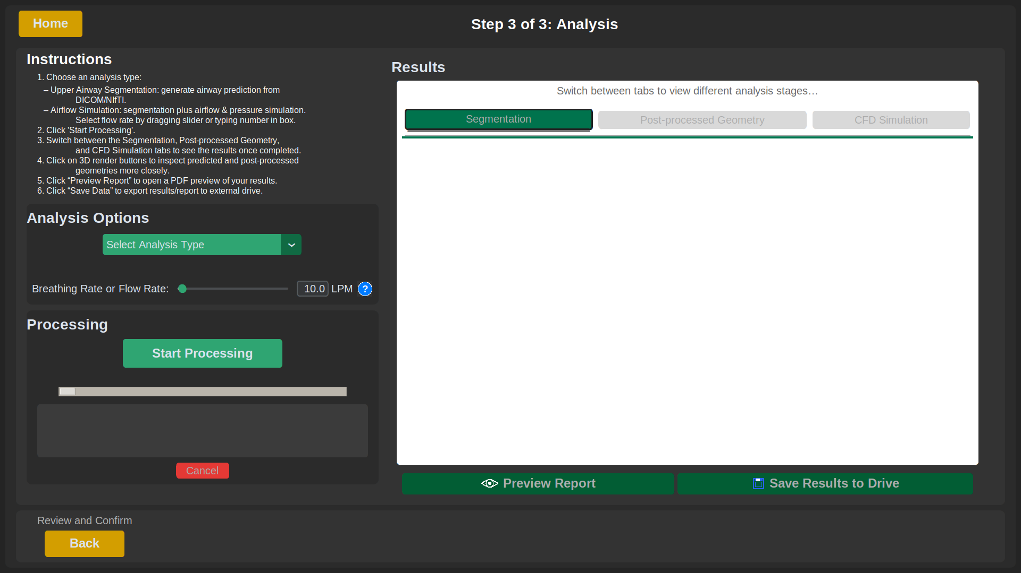

The purpose of this tab is for the user to choose and start the automated segmentation routine or the Segmentation + CFD Simulation, and save the results to their external drive.
- Select either Upper Airway Segmentation or Segmentation + Airflow Simulation.
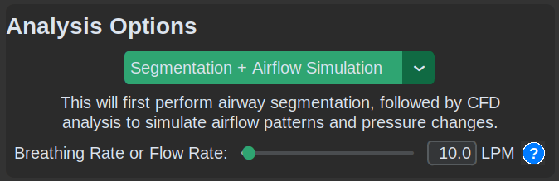
  - Selecting Upper Airway Segmentation will perform the segmentation, generate a 3D model in STL format, calculate the airway volume and (in next update) calculate the minimal cross sectional area.
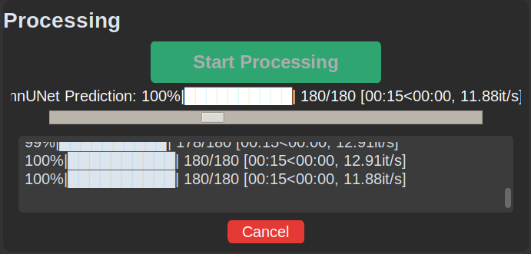
  - Selecting Segmentation + Airflow Simulation performs segmentation and also runs the airflow simulation at the chosen breathing rate, generating pressure and velocity result images.

- Click Start Processing. The on-screen log below the progress bar will display updates regarding the current processing stage.

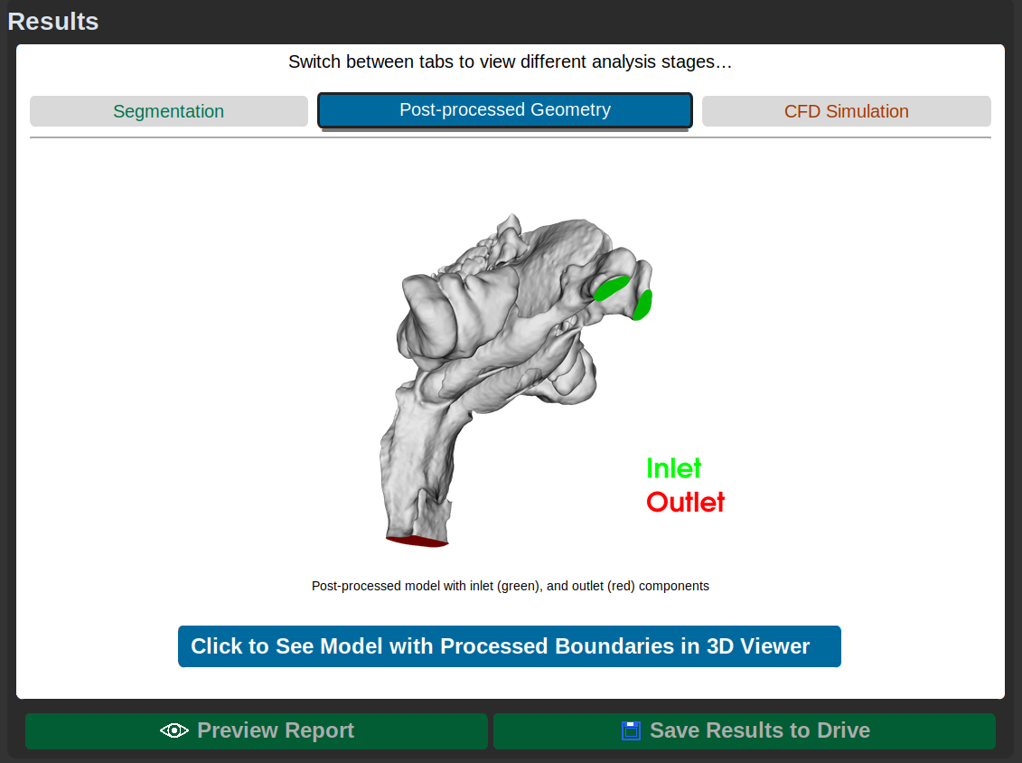
- Geometry previews appear in their respective tabs after each processing stage is complete. The 3 main processing stages are:
  - Segmentation
  - Post-processing (creating inlet and outlet)
  - CFD Simulation

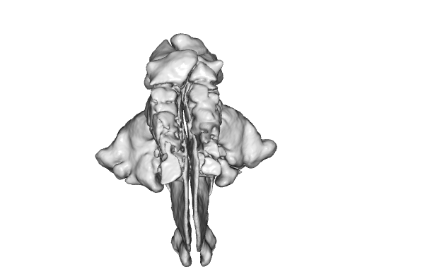
- Click the blue button below the airway preview image to open an interactive 3D viewer

- Mouse controls: Click+drag to rotate, scroll to zoom.

- Press the ESC key to exit the interactive 3D viewer

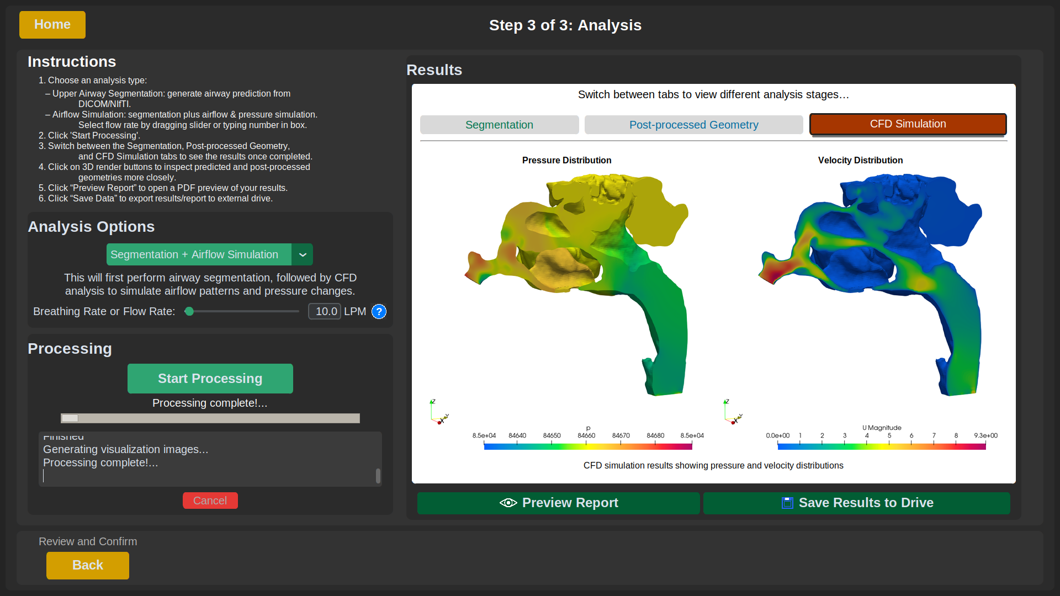
- Click Preview Report to view the results in a report format as shown in the Report Preview below.

- Click Save Results to Drive to export all files (e.g., segmentation, STL, volume, MCSA, and report) to the external drive.

- To start a new analysis or allow another user to log in, click Home to return to the login page.

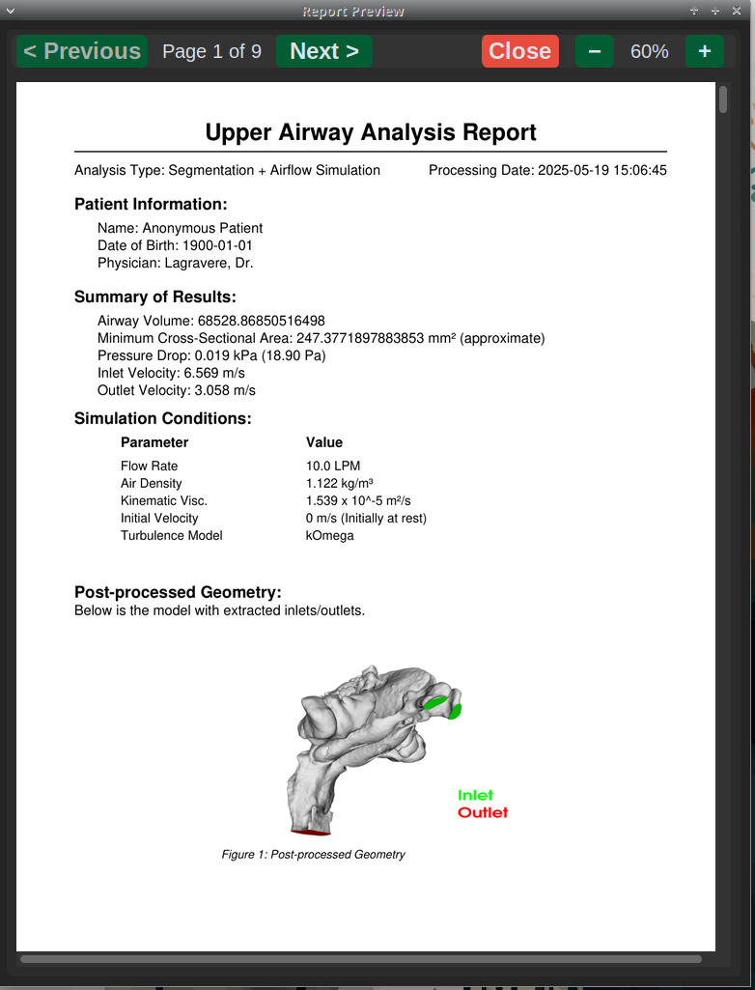Figure. Report Preview

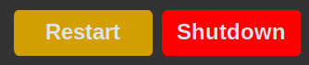
- Use the Shut Down or Restart buttons in the bottom right corner of the Analysis tab to power off or reboot the computer. If a data transfer is in progress, the system will wait until it completes before shutting down.
- Troubleshooting

Inlet and Outlet of Geometry Are Incorrectly Positioned
- Ensure that the patient scan is aligned with the Frankfort plane before segmentation.
- Proper alignment increases the chances of generating correctly placed inlets and outlets for CFD analysis.

How to log out, shut down, and/or open terminal in “locked down” cfdapp profile
The application operates within a restricted user profile configured to limit access to the computer's operating system. This security measure ensures users can only interact with the CFD application while preventing unauthorized access to system resources. However, if modifications are needed, the following key combinations can be used for shutting down the computer, logging out of the profile, or to access the terminal:
- Shift+Ctrl+Alt+Del: Opens the system shutdown confirmation dialog
- Shift+Ctrl+Alt+Backspace: Prompts for profile logout confirmation
- Shift+Ctrl+Alt+Space: Activates terminal access
Note: System commands such as Ctrl+Alt+Del have been disabled for security purposes. If the program is unresponsive and restarting the computer doesn’t solve the issue, contact for support at amatos@ualberta.ca

Error While Saving Data to External Drive
- Ensure the external drive has at least 1 GB of free space.
- Check that the drive is properly connected and recognized by the system

Airflow Simulation Taking Too Long (e.g. Over 30 Minutes)
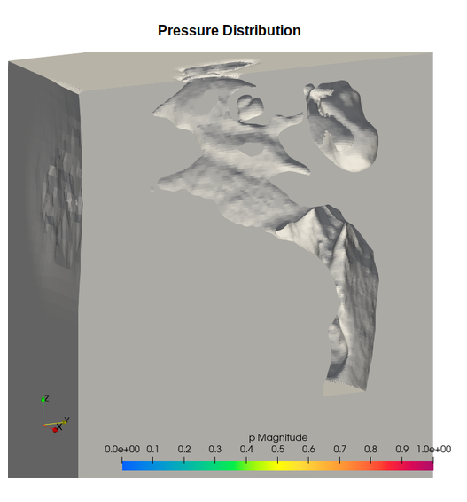
- If the simulation is taking much longer than usual, the "inside" and "outside" points (used to define the fluid region) may be incorrectly placed, causing the geometry to be interpreted inside-out (as shown on the right).
- Automating the selection of these points is planned as part of future development.
- Contact amatos@ualberta.ca and/or utummala@ualberta.ca if you have additional questions.
- Making App Modifications
The OrthoCFD app is a work in progress so in this section I will show some locations where modifications can be easily made to improve it.

Edits to Be Completed
TODO tags have been added throughout the scripts to highlight areas of the code where things should be changed. To easily locate and manage these, you can use VSCodium with the Todo Tree extension, which lists all TODO tags in the repository in one place.

Edit/Add Contributor List
To edit the contributor list, edit the json file located in the main Ortho_App folder called “contributors.json” and input the information in the following format:
{
"name": "Name",
"title": "Title",
"email": "Email",
"department": "Department"
}
Just make sure that each entry is separated by a comma and the last entry doesn’t have a comma to avoid syntax errors. If there are syntax errors the program will fallback to the original contributors (Dr. Capenakas, Dr. Lagravere, Dr. Lange, Alejandro and Uday).

Editing App Name, Theme, Appearance, Path Configurations
To change the different configurations, edit the /config/settings.py file.

How to incorporate Minimum Cross Sectional Area calculation script
The scripts currently use a temporary Minimum Cross-Sectional Area (MCSA) method. To use the correct MCSA calculation, simply replace the temporary method in /utils/segmentation.py with the proper implementation. The current method takes a geometry mesh (polydata) as input, along with the number of slices used to divide the geometry (currently set to 50).

How to edit question mark (tooltip) contents
To edit the text shown in a tooltip (question mark icon), locate the _create_info_button() method within the scripts for each tab (tab1, tab2, tab3, tab4). The tooltip text is defined within this method and can be modified directly.

Editing airway segmentation (prediction) parameters
If the user wants to modify the prediction parameters like which trained dataset it uses, whether it uses gpu or cpu, the step size, tta usage, or the number of processing threads those values can be changed in the run_nnunet_prediction method in /utils/segmentation.py.

Editing CFD simulation parameters
The CFD parameters can be found within the /Ortho_App/data/Master_cfd_file/system/.
For example:
- To modify the number of steps to perform, edit the endTime parameter (line 25) in the controlDict file.
- To modify the probe locations for the CFD computations, edit lines 143-145 in controlDict.
- It is also important to make sure that the locationInMesh is appropriate for each geometry. Check/Modify line 117 in snappyHexMesh for this.
- To modify the number of processors to use edit the numberOfSubdomains (line 17) in decomposeParDict.
- System Setup and Configuration
This section is intended for system administrators performing first-time setup.
- Device: Dell G15 5515
- Architecture: x86-64
- RAM: 32 GB
- CPU: AMD Ryzen 7 5800H (8 cores, 16 threads, base 3.2 GHz)
- GPU: NVIDIA GeForce RTX 3060 Laptop GPU (6 GB VRAM)
- Kernel Version: 6.4.0-150600.23.38-default
- Firmware Version: 1.13.0 (2023-07-12)
- OS Installed: openSUSE Leap 15.6
- Hostname: cafu
The system includes two user profiles, each configured with a different desktop environment based on their intended use:
- cfduser uses the XFCE desktop environment. This profile is configured for general use and development tasks, offering a balance between performance and user interface features.
- cfdapp uses the IceWM desktop environment. This profile is reserved for running the airway analysis application in a more lightweight and minimal environment. IceWM was selected for its low system resource usage and minimal visual distractions, making it well-suited for focused application execution.

Operating System Installation Steps
This section outlines the selections made during the installation of openSUSE Leap 15.6 on the project workstation. It is intended to help others replicate the system environment in the event of re-installation or deployment on a different machine.

Language and Keyboard Settings
- Language: English (US)
- Keyboard Layout: English (US)

Network Configuration
- Connection Type: Wi-Fi
- IP Address: Dynamic (DHCP)
- Connection Mode: Activated at boot time

Online Repositories
During installation, default online repositories were enabled to allow immediate access to updated packages and software patterns.

System Role
- Selected Role: Desktop with XFCE
This role installs a lightweight desktop environment suitable for general use and development tasks.

Partitioning
A guided setup was used with the following options:
- LVM: Not enabled
- Disk Encryption: No Disk Encryption
- Partition Scheme:
  - Root Volume:
    - File System: Btrfs
    - Size: ~300 GB
  - Home Volume:
    - File System: XFS
    - Size: ~600 GB
  - Swap Volume:
    - Type: Encrypted swap partition
    - Size: ~33 GB (matched to system RAM)

User Creation
During installation, you’re prompted to create the first user and set the root password.
- Root Password: (You can choose whether or not to mention this in the document)
- User Account:
  - Username: cfduser
  - Full Name: CFD User
  - Administrator Rights: No
  - Automatic Login: No
Later (post-install), a second user account (cfdapp) was created for running the application in a minimal environment (IceWM).

Post-OS-installation Configuration
After installing openSUSE Leap 15.6 and setting up the desktop environment, additional configuration was required to support the system's GPU and CUDA-based operations. This section describes the steps taken to install the NVIDIA driver and CUDA Toolkit (version 12.4) for use with the NVIDIA GeForce RTX 3060 Laptop GPU.

NVIDIA CUDA Installation
These steps are based on the iofficial CUDA Installation Guide for Linux:
https://docs.nvidia.com/cuda/archive/12.4.0/cuda-installation-guide-linux/index.html#pre-installation-actions
- Verify the system has a CUDA-capable GPU
sudo zypper install pciutils
sudo lspci | grep -i nvidia
- Confirm system architecture and version
uname -m && cat /etc/*release
Expected output includes x86_64 and openSUSE Leap 15.6.
- Install prerequisites
Check if GCC is installed:
gcc --version
If not, install it and PCI utilities:
sudo zypper install gcc pciutils
- Disable the Nouveau driver (conflicts with NVIDIA driver)
echo "blacklist nouveau" | sudo tee /etc/modprobe.d/blacklist-nouveau.conf
echo "options nouveau modeset=0" | sudo tee -a /etc/modprobe.d/blacklist-nouveau.conf
sudo mkinitrd
sudo reboot
After reboot:
lsmod | grep nouveau
(No output means it’s disabled)
Check Secure Boot status (must be disabled):
mokutil --sb-state
- Install the NVIDIA driver from the openSUSE repository
sudo zypper install openSUSE-repos-Leap-NVIDIA
sudo zypper refresh
sudo zypper search --details nvidia-drivers-G06
Install version 550.144.03:
sudo zypper install --oldpackage \
nvidia-drivers-G06=550.144.03-lp156.30.1 \
nvidia-compute-G06=550.144.03-lp156.30.1 \
nvidia-gl-G06=550.144.03-lp156.30.1 \
nvidia-utils-G06=550.144.03-lp156.30.1
Lock packages to avoid unwanted upgrades:
sudo zypper addlock nvidia-drivers-G06
sudo zypper addlock nvidia-compute-G06
sudo zypper addlock nvidia-gl-G06
sudo zypper addlock nvidia-utils-G06
Reboot the system:
sudo reboot
Verify driver:
nvidia-smi

- Install CUDA support and toolkit (version 12.4)
sudo zypper install -y kernel-default-devel=$(uname -r | sed 's/-default//')
sudo usermod -a -G video $USER
sudo rpm --erase gpg-pubkey-7fa2af80*
sudo zypper addrepo https://developer.download.nvidia.com/compute/cuda/repos/opensuse15/x86_64/cuda-opensuse15.repo
sudo zypper refresh
sudo zypper install -y cuda-toolkit-12-4
sudo reboot
- Verify installation and configure environment
Check CUDA compiler location:
nvcc --version
If not found, add to .bashrc:
export PATH=/usr/local/cuda-12.4/bin:$PATH
export LD_LIBRARY_PATH=/usr/local/cuda-12.4/lib64:$LD_LIBRARY_PATH
Then apply changes:
source ~/.bashrc

Software Environment Setup
This section outlines the installation steps for the required software to run the CFD app, including OpenFOAM, Blender, Python, nnU-Net, and additional dependencies.
- Install OpenFOAM and ParaView
Add the science repository and install required packages:
sudo zypper addrepo https://download.opensuse.org/repositories/science/15.6/science.repo
sudo zypper refresh
sudo zypper install openfoam
sudo zypper install blender
To install paraview:
Go to https://www.paraview.org/download/ - Choose the .tar.gz version
Extract to a shared system location (e.g., /opt):
cd /opt
sudo tar -xf ~/Downloads/ParaView-*.tar.xz
sudo mv ParaView-* paraview
Create system-wide symbolic links:
sudo ln -s /opt/paraview/bin/paraview /usr/local/bin/paraview
sudo ln -s /opt/paraview/bin/pvpython /usr/local/bin/pvpython

- Install Git and VS Codium
sudo zypper install git
For Codium get repository from: https://vscodium.com/
then: sudo zypper install codium
Open VSCodium and add relevant extensions: Python, Todo Tree
Configure Git:
git config --global user.name "capenaka"
git config --global user.email "capenaka@ualberta.ca"
Create a directory called CFD_GUI in the Desktop:
mkdir ~/Desktop/CFD_GUI
Go into newly created directory and clone the repository:
cd Desktop/CFD_GUI/
git clone https://github.com/capenaka/Airway-ML-CFD-Linux.git
- Set Up Python 3.11 and Virtual Environment
Check Python version:
python3 --version
Need at least python3.11 version. If not available, install:
sudo zypper install python311
sudo zypper install python311-virtualenv
Create a working directory and virtual environment:
python3.11 -m virtualenv ~/Desktop/CFD_GUI/GUI_env/
Activate virtual environment:
source ~/Desktop/CFD_GUI/GUI_env/bin/activate
- Install nnU-Net and Dependencies
Follow installation steps from: https://github.com/MIC-DKFZ/nnUNet/blob/master/documentation/installation_instructions.md
Install PyTorch before installing nnUNet (use 12.1 instead of 12.4 ):
pip install torch torchvision torchaudio --index-url https://download.pytorch.org/whl/cu121

Install nnU-Net:
pip install nnunetv2
Set environment variables in .bashrc file (update paths as needed):
export nnUNet_raw="/home/cfduser/Desktop/CFD_GUI/Airway-ML-CFD-Linux/nnUNet/nnUNet_raw"
export nnUNet_preprocessed="/home/cfduser/Desktop/CFD_GUI/Airway-ML-CFD-Linux/nnUNet/nnUNet_preprocessed"
export nnUNet_results="/home/cfduser/Desktop/CFD_GUI/Airway-ML-CFD-Linux/nnUNet/nnUNet_results"
- Verify:
source .bashrc
echo $nnUNet_raw
Download pretrained model weights: https://github.com/alejandro-matos/Airway-ML-CFD-Linux/releases/download/v0.3/Dataset014_Airways_155CBCT_fold_all.zip
Rename model as Dataset_014_Airways, and extract it into the nnUNet_results folder

- Give special permission to users to be able to shut down or restart the computer from the GUI directly:
sudo visudo
Add this:
##
## User privilege specification
##
root ALL=(ALL:ALL) ALL
cfduser ALL=(root) NOPASSWD: /sbin/shutdown, /sbin/reboot
cfdapp ALL=(root) NOPASSWD: /sbin/shutdown, /sbin/reboot

- Additional Python Packages
Install tkinter
sudo zypper install python311-tk
Install all required Python packages for the GUI app:
pip install -r requirements.txt
Contents of requirements.txt:
customtkinter
open3d
reportlab
vtk
PyMuPDF
frontend
Note on nnU-Net Package Dependencies
nnU-Net installs a large set of python libraries for:
Deep learning
Medical image handling (DICOM, NifTI)
Scientific computing
Visualization
Utilities
These include: torch, SimpleITK, nibabel, pandas, scikit-learn, matplotlib, requests, urllib3, and more. A full list can be found in the nnU-Net documentation.

Creating Restricted User Profile
To ensure a secure and minimal environment for running the CFD GUI application, a dedicated Linux user account (cfdapp) was created. This profile is configured to log in automatically on boot, use a lightweight window manager (IceWM), and run the application in a kiosk-style mode with limited system access.

User Creation and Autologin Setup
- Create the user account and set a password
sudo useradd -m cfdapp
sudo passwd cfdapp
# set temporary password
su cfdapp #use password
# Modify authorization to allow for blank password to log in
sudo nano /etc/pam.d/common-auth
Change this: auth required pam_unix.so try_first_pass
To this: auth required pam_unix.so nullok try_first_pass
- Install LightDM if not already installed
sudo zypper install lightdm
- Configure LightDM for autologin
Edit the configuration file:
sudo nano /etc/lightdm/lightdm.conf
Add or update the following lines:
[Seat:*]
autologin-user=cfdapp
autologin-session=cfdapp

Setting display manager
sudo nano /etc/sysconfig/displaymanager
DISPLAYMANAGER="lightdm"
sudo systemctl disable display-manager.service
sudo systemctl enable lightdm.service

Window Manager and Session Script Setup
- Install IceWM as the window manager
sudo zypper install icewm
- Create a custom session script. Save the following in a file in /usr/local/bin/cfdapp-session and make it executable:
#!/bin/bash
export DISPLAY=:0
# Start udiskie so removable drives auto-mount under /run/media/cfdapp
udiskie &
icewm --no-startup-id &
WM_PID=$!
sleep 1
LOGFILE="/home/cfdapp/cfdapp_log.txt"
start_app() {
echo "[INFO] Starting app at $(date)" >> "$LOGFILE"
source /home/cfdapp/Desktop/CFD_GUI/GUI_env/bin/activate
echo "[INFO] Activated virtualenv" >> "$LOGFILE"
cd /home/cfdapp/Desktop/CFD_GUI/Airway-ML-CFD-Linux/Ortho_App_reorg || {echo "[ERROR] Failed to change directory" >> "$LOGFILE"return 1
}
python /home/cfdapp/Desktop/CFD_GUI/Airway-ML-CFD-Linux/Ortho_App_reorg/main.py
EXIT_CODE=$?
echo "[INFO] App exited with code $EXIT_CODE" >> "$LOGFILE"
return $EXIT_CODE
}

MAX_RESTARTS=5
RESTART_COUNT=0
while true; do
start_app
APP_EXIT=$?
if [ $APP_EXIT -eq 42 ]; then
break
fi

RESTART_COUNT=$((RESTART_COUNT + 1))
if [ "$RESTART_COUNT" -ge "$MAX_RESTARTS" ]; then
echo "[ERROR] App crashed too many times. Exiting session." >> "$LOGFILE"
break
fi
sleep 0.2
done
kill $WM_PID

- Make file executable
sudo chmod +x /usr/local/bin/cfdapp-session

- Create a desktop session entry. Save this to /usr/share/xsessions/cfdapp.desktop:
[Desktop Entry]
Name=CFD App Session
Comment=Run IceWM and CFD App
Exec=/usr/local/bin/cfdapp-session
TryExec=/usr/local/bin/cfdapp-session
Type=Application

- Ensure the .dmrc file reflects the session name. After login, it should contain:
[Desktop]
Language=en_US.utf8
Session=cfdapp

- Copy the GUI project to the restricted user’s desktop and fix ownership:
sudo cp -r /home/cfduser/Desktop/CFD_GUI /home/cfdapp/Desktop/
sudo chown -R cfdapp /home/cfdapp/Desktop/CFD_GUI
- Reinstall the virtual environment as done previously for cfduser
- Make sure to add user to video group to ensure GPU access

Disabling UI Features and Keyboard Shortcuts
To limit enhance security and streamline functionality, many functions were disabled to stop the user from exiting the application and getting access to the full computer without administrator privileges.
- Edit IceWM preferences
nano ~/.icewm/preferences
# Disable workspace switching
WorkspaceNames=""
EdgeResistance=10000
# Disable most window operations
ShowMenuButton=0
ShowTaskBar=0
ShowMenuButton=0
ShowClock=0
ShowAPMStatus=0
ShowNetStatus=0
ShowWindowListMenu=0
TaskBarShowWindowList=0
TaskBarShowStartMenu=0
TaskBarShowWorkspaces=0
# Hide the taskbar completely
TaskBarAutoHide=0
TaskBarAutoShow=0
TaskBarShow=0
# Disable window border buttons (minimize, maximize, close)
TitleButtonsLeft="" TitleButtonsRight=""
# Disable key combinations
KeySysWorkspace1=""
KeySysWorkspace2=""
KeySysWorkspace3=""
KeySysWorkspace4=""
KeySysWinMenu=""
KeySysMenu=""
KeySysWindowList=""
KeySysWinListMenu=""
# Disable alt+tab window switching
KeySysWinNext=""
KeySysWinPrev=""
# Disable window movement and resizing
ClientWindowMouseActions=0
# Disable minimize buttons for all windows
MinimizeButton=0

- Further disable certain key combinations
nano ~/.icewm/keys
file contents:
# Disable Alt+F4 (normally closes windows)
key "Alt+F4" ""
# Disable Ctrl+Alt+T (normally opens terminal if configured)
key "Ctrl+Alt+T" none
key "Ctrl+Alt+Delete" none
# Ask question before shutdown with shortcut
key "Ctrl+Alt+Shift+Delete" /usr/local/bin/confirm_shutdown.sh
# Add custom key combination for getting terminal
key "Alt+F2" ""
key "Ctrl+Alt+Shift+space" xterm
# Add quick logout shortcut
key "Ctrl+Alt+Shift+BackSpace" /usr/local/bin/confirm_logout.sh

- Ctrl+Alt+Delete seems to keep working despite the above so create a config snippet file:
sudo nano /etc/systemd/logind.conf.d/disable-ctrlaltdelete.conf
Paste the following inside:
[Login]
CtrlAltDelBurstAction=none

- Since the windows key refuses to deactivate with the previous things create the following file:
nano ~/.Xmodmap
With content:
‘keycode 133 = NoSymbol’
‘clear mod4’
- Install Zenity for confirmation dialogs functionality
sudo zypper install zenity
- Create logout and shutdown scripts
/usr/local/bin/confirm_shutdown.sh
#!/bin/bash
zenity --question --title="Shutdown Confirmation" --text="Do you want to shut down the computer?"
if [ $? -eq 0 ]; then
systemctl poweroff
fi
/usr/local/bin/confirm_logout.sh
#!/bin/bash
zenity --question --title="Logout" --text="Do you really want to log out?"
if [ $? -eq 0 ]; then
SESSION_ID=$(loginctl | grep $(whoami) | awk '{print $1}')
loginctl terminate-session "$SESSION_ID"
fi
- Make both scripts executable:
sudo chmod +x /usr/local/bin/confirm_shutdown.sh
sudo chmod +x /usr/local/bin/confirm_logout.sh
- To enable external drive mounting functionality, need to install these:
sudo zypper install udiskie udisks2
sudo zypper install python3-importlib-resources
- App Development Guide
The OrthoCFD app was developed in Python 3.11, with a graphical interface built using customtkinter. It connects external tools like Blender, OpenFOAM, ParaView, and nnUNetv2 through Python scripts and parameter files.
Originally created by Uday Tummala, the app was later expanded and restructured by Alejandro Matos Camarillo to improve automation, stability, and usability for clinical and research users.
The GUI handles user input, process control, and output display. It supports DICOM and NIfTI scans, and produces simulation-ready 3D models and airflow metrics.

Project Folder Structure
project_root/
├── main.py # App entry point – initializes environment and launches GUI
├── blender_ortho.py # Blender integration for STL preprocessing
├── paraview_ortho.py # ParaView automation for post-processing
├── geo_in.txt, sdir.txt # Temporary files for passing paths between components
├── contributors.json # File containing contributor details
├── logs/ # Log files generated during runtime

├── data/
│ ├── Master_cfd_file/ # Template OpenFOAM case directory
│ └── Master_cfd_file_backup/ # Backup of the default case

├── gui/
│ ├── app.py # Main GUI logic and window manager
│ ├── components/ # UI components (buttons, forms, dialogs)
│ ├── config/ # Configuration files (logging, settings, error messages)
│ ├── tabs/ # Scripts for each GUI tab (tab1.py to tab4.py)
│ └── utils/ # Helper scripts for segmentation, reports, file handling

Notes:
- main.py is the launcher, and the rest of the top-level .py scripts handle key tool integrations.
- data/ holds the OpenFOAM template case used to copy simulation files during runtime.
- gui/ is the core of the interface, containing layout logic, tab navigation, and all support utilities.

Overview of Main Modules
All Python scripts in this project are thoroughly commented to improve readability and support future maintenance or modification. Each module is designed with a specific role in the workflow, and variable/function names follow consistent naming conventions to enhance clarity.

main.py
Acts as the entry point for the app. It sets up the working environment, checks for required external tools, and launches the GUI. It also logs runtime activity.
- Key Components:
  - setup_environment(): Creates 'logs' folder and checks for Blender, OpenFOAM, ParaView
  - handle_exception(): logs the error and shows a simple popup directing the user to check the log file.
  - main():
    - Calls setup_environment(), logs success or shows an error popup.
    - It creates the OrthoCFDApp window, sets up what happens when the user closes the app, and then starts the main program loop.
  - on_closing(app): Logs a closing banner with timestamp, and calls app.destroy().

blender_ortho.py
This script runs in headless Blender mode to preprocess the segmented airway STL file. It aligns and cleans the model, creates inlet and outlet surfaces, exports a cleaned STL, and generates a rendered image for preview.
- Key Components:
- STL Import and Alignment: Reads input/output paths from geo_in.txt and sdir.txt, imports the STL, and aligns it to a consistent orientation and position.
- Mesh Cleanup and Separation: Removes artifacts, cuts the geometry, and separates it into named components (wall, inlet, outlet).
- Boolean Operations: Uses cubes and boolean modifiers to define and separate inlet and outlet regions.
- STL Export: Exports the processed geometry to OpenFOAM’s triSurface folder for simulation use.
- Image Rendering: Applies materials, adds lighting, positions the camera, and renders a JPEG preview image (blendout.jpg).
- Runtime Logging and Exit: Prints completion messages, time taken, and quits Blender automatically.

paraview_ortho.py
This script runs in headless ParaView mode to post-process OpenFOAM simulation results. Applies color maps to pressure (p) and velocity magnitude (U) data and saves multiple full-model views from different angles. It generates screenshots of pressure and velocity fields, sectional views, and streamlines, saving them as PNG files for reporting and analysis.
- Key Components:
  - Sectional Views: Uses clipping planes to visualize cross-sections of the airway and saves images showing pressure and velocity distributions.
  - Streamline Visualization: Generates streamlines of airflow using ParaView’s StreamTracer and Tube filters and exports 2D and 3D views.
  - Image Export: Saves all outputs as .png files in the same directory as the OpenFOAM case.
  - Runtime Logging: Prints status updates and total execution time before exiting.

gui/app.py
Main controller for the GUI. Initializes the application window, configures tabs, manages variables, and handles navigation between steps.
- Key Components:
  - setup_window(): Configures the main window title, fullscreen mode, and icon.
  - initialize_variables(): Sets up all default state variables for patient info, UI elements, and workflow flags.
  - init_tab_managers(): Creates instances of the tab classes (Tab1Manager to Tab4Manager).
  - setup_gui(): Builds the main frame and displays the first tab by default.
  - Tab Creation Methods (create_tab1 to create_tab4): Each creates and displays the corresponding step in the GUI.
  - Navigation and Reset (go_home, clear_main_frame, clear_all_data): Clears the interface and variables to return the app to its initial state.
  - Validation (validate_tab2): Checks required inputs in Tab 2 before allowing the user to proceed.
  - Folder Management (get_existing_folders, update_folder_dropdown): Retrieves and displays existing folder options for a given patient and user.

gui/utils
This folder contains helper scripts that support core functionality such as segmentation, report generation, file handling, and visualization.
- Key Scripts:
  - image_processing.py: Contains functions that support both NIfTI and DICOM input workflows for accurate image orientation, display and labelling
  - segmentation.py: Full pipeline controller for airway segmentation using the trained nnUNet model and STL generation using VTK libraries.
  - blender_processor.py: This module handles all blender-related operations such as creating inlet and outlet geometries, generating assembly preview image, managing blender cancellation procedures
  - open3d_viewer.py: Provides fullscreen 3D viewers for STL files of segmentation and post-processed geometry
  - generate_airway_report.py: Builds the final PDF report with volume, pressure drop, and velocity data
  - get_cfd_data.py: Parses OpenFOAM outputs and extracts key simulation results.
  - image_processing.py: Contains functions that support both NIfTI and DICOM input workflows for accurate image orientation, display and labelling
  - stl_assem_image_render.py: Used for STL rendering of airway geometry after creation of inlet and outlet from Blender, preview generation, and image cleanup.
  - basic_utils.py: Contains methods for logging data

gui/config
Holds configuration files that control app behavior and environment setup.
- Key Scripts:
  - settings.py: Centralizes settings for paths, UI appearance, and placeholders.
  - logging_config.py: Defines the logging format and log file locations.
  - error_messages.py: Stores reusable error messages for GUI popups.

gui/components
Contains reusable UI elements and custom widgets used throughout the app to maintain consistency and reduce repetition.
- Key Scripts:
  - progress.py: Creates progress bar, status messages, and output logs, and includes the cancel button from Tab4 with confirmation and safe threading support.
  - buttons.py, forms.py, dialogs.py: Define the structure and style of common interface elements.
  - navigation.py: Provides the navigation bar used to move between tabs.
  - pdf_viewer.py: Embeds PDF previews directly in the app interface.
  - custom_notebook.py: Contains the logic for managing tabbed content inside the GUI.

Other supporting files: geo_in.txt and sdir.txt
In addition to the main scripts and modules, the app uses two simple text files to pass data between components and coordinate workflow steps across separate tools:
- geo_in.txt: This file stores the full path to the STL file generated after segmentation. It is read by the Blender processing script (blender_ortho.py) to load and process the geometry automatically.
- sdir.txt: This file stores the path to the current simulation output folder. It is used by both Blender and ParaView scripts to know where to save processed models and CFD visualizations.

- Troubleshooting
This section lists a few known issues and simple actions to resolve them when the app or simulation behaves unexpectedly.

Python
- Unexplained Syntax Error
If a syntax error appears even though the code is correct, it likely means you're using an outdated version of Python that doesn't support the newer syntax.
Solution: Make sure the correct Python version (3.11) is installed and/or that the python virtual environment is activated before running the app.

Blender
- Blender Geometry Processing Fails
Possible Causes:
  - The input STL file is missing, corrupted, or wasn't created during segmentation.
  - geo_in.txt does not contain the correct or full path to the STL file.
  - Blender is missing Python modules or the script hit a runtime error (e.g. during Boolean operations).
Solutions:
- Confirm that geo_in.txt points to an existing .stl file and that it was correctly generated by the segmentation step.
- Make sure Blender was installed properly and that the system has a working OpenGL-compatible environment.
- If image export fails but STL works, verify Blender is not in offscreen mode and the system has an active display (needed for rendering with lights/camera)

OpenFOAM
- Simulation running slower than usual
Occasionally, OpenFOAM may run significantly slower than expected due to system resource issues or leftover background processes.
Solution: Restart the computer to clear any lingering processes and reset system resources.

- Future CFD Application Improvements
While the current GUI provides a complete end-to-end workflow, there are several areas that could be improved to enhance usability and/or generalizability:
- Develop a better username system in case there are two people with the same last name
- Develop an algorithm to automatically extract the inlet, outlet, and inside points from an STL or mesh geometry for use in the CFD setup files.
- Implement a simpler alignment algorithm in Blender by using provided manually aligned scans or training an AI scan alignment algorithm to ensure the successful creation of an inlet that meets these criteria:
  - The plane of cutting must be perpendicular with respect to the septum.
  - Plane of cutting must also be perpendicular with respect to the septum
  - Method chosen is robust enough to be effective even with the variance in anatomical features
  - Entry to airway doesn’t cause flow to overlap/mix with the other side
- Add support for region-based pressure drop analysis: It would be valuable to view the pressure drop across anatomical regions like the soft palate. This would give more clinically relevant insights into airflow resistance and help evaluate treatment impact more precisely.
  - This would need to include an image in the results that relates slices to locations in the geometry.
- Implement proper Minimum Cross-Sectional Area calculation. A placeholder has been added for now.
- Implement an AI-assisted method of landmark identification for defining anatomical regions in patient scans for a more objective region definition and scan alignment

